OPEN CALL – Gallery Vltavská
on January 28, 2021, for curators, curator groups, artists and art groups

The Prague City Gallery hereby announces an open call for proposals and realization of short-term exhibition projects in 2021 in the new exhibition area near the Vltavská Underground Station.
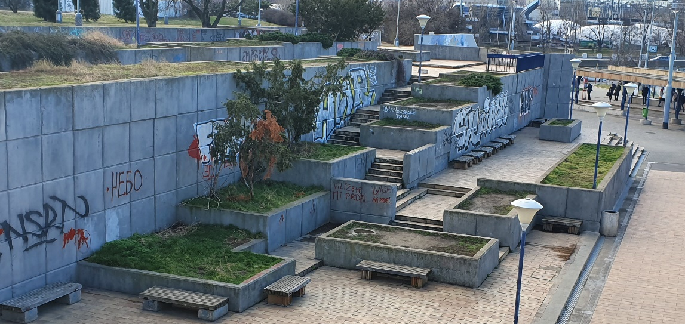

The program “Art for the City”, organized by the City of Prague to support contemporary art in the public space, started in 2018. This year, the support has extended to temporary installations and short-term art interventions in the public space. They include the planned outdoor gallery using the supporting walls above the Vltavská underground station. The cascaded terraces will soon give way to the new architectural concept of the Bubny neighborhood, and the piazetta around the projected concert hall. Currently, the area is neglected, abandoned and decaying. Until the reconstruction starts, the Prague Public Transit Company will offer the area to the outdoor gallery for exhibitions that will take turns in 3-month periods.
For the pilot period of this outdoor gallery, the Prague City Gallery decided to invite street photographer Kevin V. Ton. The topic of the exhibition is simple and easy to understand: People from Vltavská. It also responds to the current pandemic that has affected the lives of people on the street as well as all indoor exhibitions. The exhibition will take place until March 25, 2021.

- WHO CAN RESPOND TO THE CALL?
Curators, artists, and curator or art groups. The call is non-anonymous, open for anyone.

- ESTIMATED OUTDOOR EXHIBITION PERIODS:
T1 April 1 – June 25, 2021
T2 July 1 – September 25, 2021
T3 October 1, 2021 – January 25, 2022

- PROJECT THEMES
- There are no fixed themes for the projects at Gallery Vltavská.
- The theme or topic should fit into the context of the urban environment, and sensitively respond to the functions and social / historic relations in the location.
- The theme, contents or form of the exposed artworks must not be vulgar or support any undemocratic political systems.

- LOCATION / AREA:
Supporting walls above the Vltavská underground station and the adjacent cascaded terraces.
There’s a long history of legal graffiti around the Vltavská station. The installation of large exhibition panels, with possible use of staircases, offers specific approaches and themes. That said, sensitive approach to the surrounding architecture is required.

- TECHNICAL PARAMETERS OF THE INSTALLATION
A modular system of exhibition frames is available (marked turquoise in the visualization), to be fitted with large canvases or banners. The maximum available dimensions and the maximum numbers of canvases is displayed; the size canvases can be decreased in 1-meter steps. The system can be installed on structured walls, respecting its 1 x 1 meter segments.
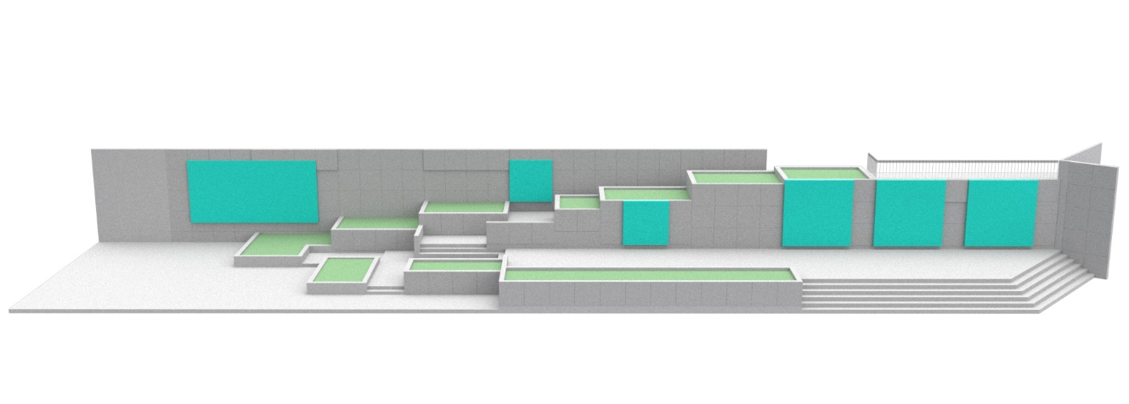
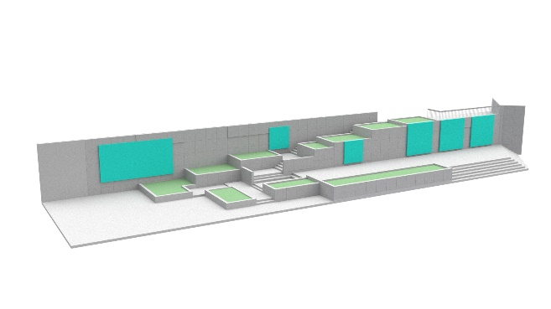
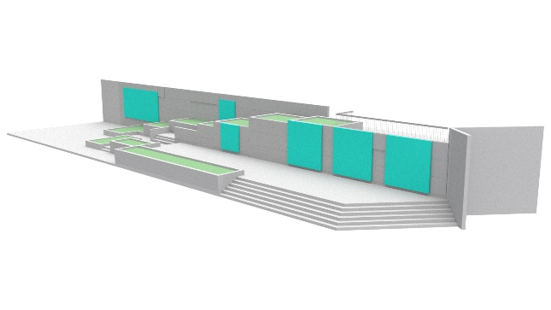
The dimensions of the frames can be increased or decreased as needed. It isn’t necessary to use all the frames. The system consists of these fragments:
1st modular element / corner frame – 24 pcs – aluminum profile 50x50x2mm / 2x plywood 9mm / 1000x1000x50mm
2nd modular element / edge frame – 22 pcs – aluminum profile 50x50x2mm / 1x plywood 9mm / 1000x1000x50mm without PU
3rd modular element / central frame – 7 pcs – aluminum profile 50x50x2mm / 1000x1000x50mm
4th modular element / wall mounting – 24 pcs – aluminum plate 50x2mm / 50x200x2mm

- MAXIMUM BUDGET FOR AN EXHIBITION IN A SINGLE PERIOD T1/T2/T3:

150,000 Czk, VAT included

- This budget must include all project costs, including the costs for the necessary production team, fees for curators and artists, all material needed for the realization of the exhibition, large prints of banners, additional staff and services, or subcontractor fees for various supplies, loans of technology, scaffolding, transport costs etc.
- The project and its budget must also include the graphic design of the exhibition (the visual presentation, captions, outdoor credit panel etc.).
- The budget must also include the dismounting of the exhibition by the production team appointed by the curator.
- Any required repairs or adjustments of the surrounding areas must also be included in the budget.
- If the project needs energy supply or security service, the relevant costs must also be included in the budget.

- STRUCTURE OF THE PROPOSAL:
- Project theme, concept, vision of the impact on viewers and relations with the surrounding areas (text).
- Brief profiles of authors, and/or the portfolio of the curator/artist.
- Estimated budget for the realization (including all fees for curators and artists, and costs for materials and the realization, including required services)

REQUIRED ATTACHMENTS:
- Application form.
- Visualization of the project in print quality for at least A3 size (technical sketch, illustration, study, project documentation or computer-based visualization).

The proposal should give the Committee a sufficient idea of the result and project feasibility.

- AWARDS – for each exhibition period T1/T2/T3:
1st place – Czk 30,000
2nd place – Czk 20,000
3rd place – Czk 10,000

- assessment CRITERIA:

- Project originality, artistic value and quality of the topic, curator’s or author’s concept, communication abilities of the project
- Local context – the specific nature of the surroundings, including historic, cultural and social relations
- Feasibility – respect to the local limits, rules and safety standards, and the presence of people in the public space

- ADDITIONAL INFORMATION ON THE PROJECT:
- The Gallery Vltavská Project is part of the program “Art for the City”. The Prague City Gallery is the guarantor of the program and also the curator of the UM 2020 project for temporary interventions of contemporary art in the public space. The funding of the call and realizations of the projects in the program “Art for the City” is provided by the Prague City Gallery.
- The Prague Public Transport Company is the partner of the program “Art for the City” and of the Prague City Gallery.
- The size (dimensions) of the art intervention is not specified. The Prague City Gallery has provided ready-made modular frames for large-scale printing on canvas; however, their use isn’t binding.
- The appropriation of the area (if necessary) for the time of the installation and dismounting of the project is organized by the Prague City Gallery; it’s not a part of the budget.
- The budget will be considered binding. The winning project must be realized under the terms of the budget.
- The proposals will not be evaluated based on their economic features.
- The proposals must respect the principles of the open and democratic society.
- The sensitive integration into the surroundings is expected. No part of the project can cause any hazard to the public or transport.
- The financial reward will be provided for three of the best proposals for each period T1, T2, T3 separately, based on the Committee verdict. Only the winning proposal will be selected for the realization in each period. In case the Committee doesn’t announce the winner, there will be no realization and the organizer will make another call.
- All artworks that are part of the realized project will be placed in the area for no more than the official exhibition period.
- Neither the Prague City Gallery nor the Prague Public Transport Company provide constant security supervision of exhibited artworks and prints. In case of a substantial damage of the prints during the exhibition period, terms of repairs will be negotiated with the authors. The Prague City Gallery provides no warranty for the 3D installations.

- TERMS AND DEADLINES FOR APPLICATION FORMS:

- Please send your completed application forms, with required attachments, until the midnight of March 3, 2021 to the following e-mail address: umenipromesto@ghmp.cz
- A proposal, with a completed application form and required attachments, can be submitted for multiple terms. The applicant should specify the preferred terms in the application form.
- PDF or JPG files are preferred. Please keep the size of the attachments below 10 MB.

- ANNOUNCEMENT OF THE RESULTS:

The winning and awarded proposals will be announced on March 15, 2020, on the website https://umenipromesto.eu.
The Prague City Gallery considers the submitted projects binding; a contract for work will be signed with the winner. The Prague City Gallery also reserves the right to withdraw from the competition in case of insufficient number of applicants. In case of poor quality of the proposals, the Prague City Gallery reserves the right to refuse the realization. The proposals submitted within the deadline, including the required attachments, will be assessed by the Committee consisting of art theoreticians, curators, architects and representatives of the Prague City Hall, city districts and location owners. There is no appeal possible against the decision of the Committee.
The lineup of the Committee will be published on the website of the project “Art for the City”: https://umenipromesto.eu until February 15, 2021.
A written record will be made the meeting of the Committee, including the list of all evaluated artworks and the verdicts. The record will include the list of all attending Committee members, with their signatures. The meeting of the Committee isn’t publicly accessible.

- CONTACT INFORMATION:
In case of any questions, please feel free to contact us at umenipromesto@ghmp.cz
Via e-mail, you can also arrange for a personal consultation or ask for details regarding the conditions, or for assistance in making the presentation.

- important dates:
Announcement of the call: January 28, 2021

Deadline for proposals: March 3, 2021 (until midnight)

Announcement of the results: March 15, 2021

Installation and exhibition periods:
- Until March 31, 2021 – ( T1: April 1 – June 25, 2021)
- Until June 30, 2021 – ( T2: July 1 – September 25, 2021)
- Until September 30, 2021 – ( T1: October 1 – January 25, 2022)

