OPEN CALL – CONFLUENCE 2022
February 21, 2022
The Prague City Gallery, in cooperation with the project “Interpretation of Landscape Aspects Through Humanities and Art” conducted by the Prague Institute of Planning and Development, Academy of Performing Arts and University of Economics, announces an open non-anonymous call for proposals and realization of temporary artworks and minor art/architectural interventions, in the location under the Lahovice Overpass, in the floodplain of the future Suburban Park Soutok (Confluence).
The realization of the winning projects is planned in summer 2022.

INTERVENTIONS:
- Summer Solstice, June 17 to 21, 2022 – 3-day art festival
- Shepherd’s Hide – artistic visual and functional object
- Lab of Change – mobile and interactive scene / object

TARGET AUDIENCE OF THE CALL:

Artists, architects, designers.

TERMS AND CONDITIONS FOR APPLICATIONS:
- Please submit the completed application forms with required attachments until April 7, 2022 (the deadline is midnight) to the following addresses:
umenipromesto@ghmp.cz and anna.gumplova@ghmp.cz
- Only one proposal, with the appropriate application form and required attachments, can be submitted per intervention.
- Preferred are documents in PDF or JPG formats, with attachments below 10 MB.

PROPOSAL PARAMETERS:
- Concept proposal / vision of the work in the area (text, max. 500 characters).
- Proposal of an art intervention in the print quality (sketch, study, project documentation or computer visualization, and/or video/audio).

REQUIRED ATTACHMENTS TO THE PROPOSAL:
- Application form
- Portfolio with examples of the author’s approach to the public space
- Budget

CONTEXT OF THE CALL:
The call for art interventions, in order to build the Interpretation Centers at the confluence of Berounka and Vltava rivers, is based on the research project “Interpretation of Landscape Aspects Through Humanities and Art” conducted by the Prague Institute of Planning and Development, Academy of Performing Arts and University of Economics. The project is support by the Technology Agency of the Czech Republic.
The aim of the project “Interpretation of Landscape Aspects” is to enable people to meet in the open landscape, find deeper contact with nature, and search the best possible way of promoting the cultural, historical and environmental values of the suburban landscape at the confluence of Berounka and Vltava rivers.
An important aspect of the project is the identification of people with the suburban landscape, and the sustainability of the project through active involvement of local residents. Based on expert analyses and research studies of the project “Interpretation of Landscape Aspects Through Humanities and Art”, the researchers (Prague Institute of Planning and Development, Academy of Performing Arts and University of Economics) will gradually establish the Interpretation Centers to promote sociological, biological, cultural, historical, environmental, and economical aspects of the area.
The Interpretation Centers
- The human presence and diversity in the floodplain
- The live river – what the river says
- Circulation of water in the landscape
- The pastures and the new wild
- Landscape as spiritual space

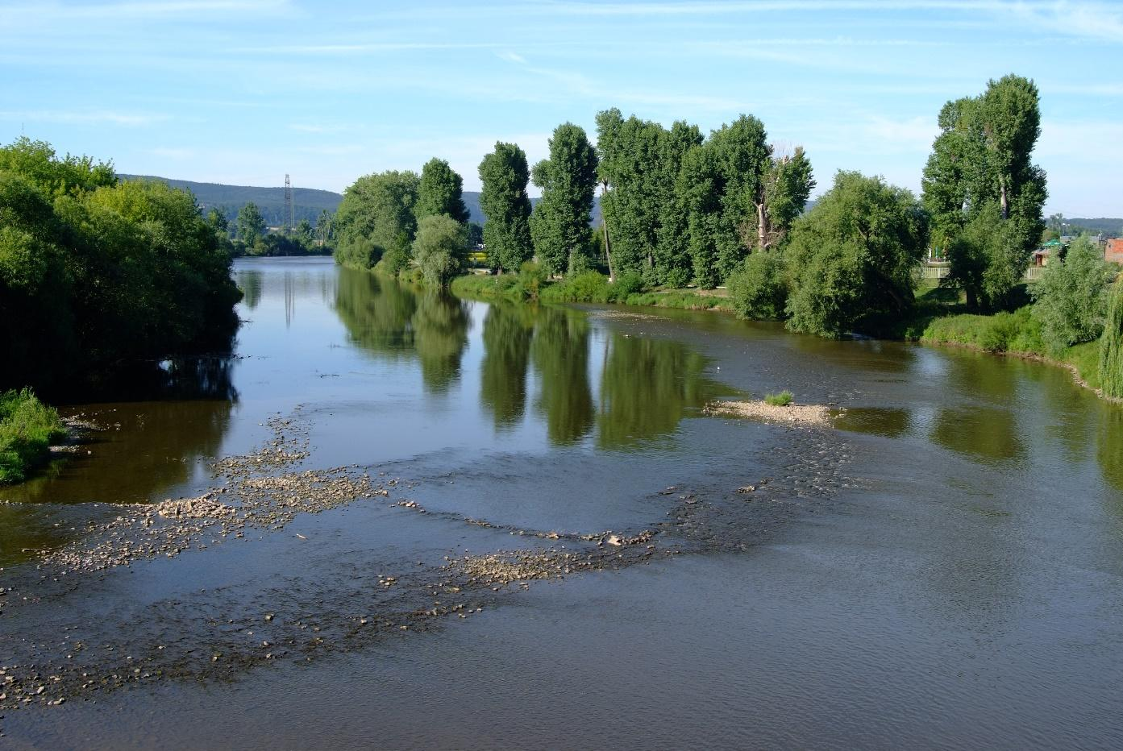

CONFLUENCE 2022
We’re building an imaginary bridge between the art in the public space, ephemeral interventions, land art, performative art formats and scientific interpretation of the landscape, using science and humanities. The use of numerous research and creative methods is expected, from empirical residencies of artists in the landscape, over the artistic-urban acupuncture that considers cities and urban landscape live organisms with sensitive points that needs repairing, to transdisciplinary processes enabling scientists and artists to cooperate and share theoretical models based on concepts specific for each discipline.

Using various means of interpretation (installations, events, performances, photos, movement, audio, video…) helps people identify with the suburbs and the urban wild.

- Three themes and locations for art interventions were prepared for the project. The application form must be submitted for each part separately. There can be no more than 3 application forms per participant.
- The essential assessment criteria will be the quality and originality of the artistic intervention.
- All proposals must respect the principles of the open and democratic society.
- No maximum size of the artwork is defined. The sensitive integration into the surroundings is expected. No part of the project can cause any hazard to the public or transport.
- The financial reward (1st, 2nd and 3rd place) will be provided for three of the best proposals for the 2nd and 3rd intervention (Shepherd’s Hide / Lab of Change). The winning project will be realized.
- In case of the intervention No. 1 (Summer Solstice), multiple proposals will be picked by the Committee verdict. The authors will get the grant to finish the proposals, which will then be realized during the 3-day festival “Summer Solstice”.

- SUMMER SOLSTICE
Date: July 17 to 21, 2022
Maximum budget for the realization of a single intervention: CZK 150,000.
The art festival “Summer Solstice” is a 3-day happening in the area under the Lahovice Overpass (the official name is the Radotín Bridge).
Temporary installations in the area under the bridge are based on the 5 themes of the project “Interpretation of Landscape Aspects”, i.e. The human presence and diversity in the floodplain, The live river – what the river says, Circulation of water in the landscape, The pastures and the new wild, and Landscape as spiritual space. They can correspond to the opening of the interpretation center “The Pastures and the New Wild”. The project can use the whole area from the intersection of the overpass and Výpadová Street to the A1 bike track along the Berounka River.
Key themes: solstice, variability of the floodplain and the river basin, gigantic architecture, traffic temple, urban wild, pastures nearby, no one’s land, the dialogue of the new wild with the technocratic outcome of the civilization, the natural qualities and dynamics of the river, irreversible marks of human presence in the landscape, the feeling of the landscape, domestication
Art form: site specific installation, multimedia installation (lighting, audio, video…), performance, happening, concept art, art research

Ideas for potential interpretation and education:
- interactions of the river and groundwater (monitoring of the surface temperatures with a thermal IR camera, different qualities of water in the two rivers reflecting their respective basins (color, chemical composition, clay, sand, gravel)
- the tradition of raftsmen and fishermen
- coexistence of humans and grazing animals, in the art from ancient bucolic landscape paintings over Bethlehem scenes with shepherds to 19th century landscapes. A grazing animal radiates peace and quiet, in contrast to these rapid, stressful times.
Community and action potential: Community joy, exuberance, bacchanalia, masks, old tales, fables, local songs, staged public agricultural events
The jury, consisting of representatives of the participating institutions and independent experts, will pick up at least 5 proposals. The maximum number of selected proposals is limited by the festival budget. The selected proposals will be realized during the 3-day art festival “Summer Solstice” that will offer many additional events and activities.
The grant for the completion of the proposals for the necessary administrative procedures (drawings of locations into maps, description of the proposal and project, technical specifications, detailed plans of installation, cooperation in pre-production etc.) will be Czk 10,000 for each selected proposal.
The art installations can remain in place for longer if agreed with the land owners, provided the relevant permits will be obtained from the authorities as required by valid legislation.
The location of the area(s):
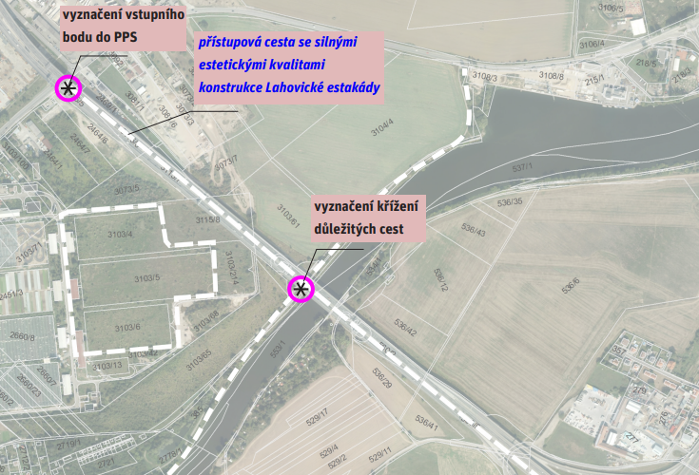
Photos:
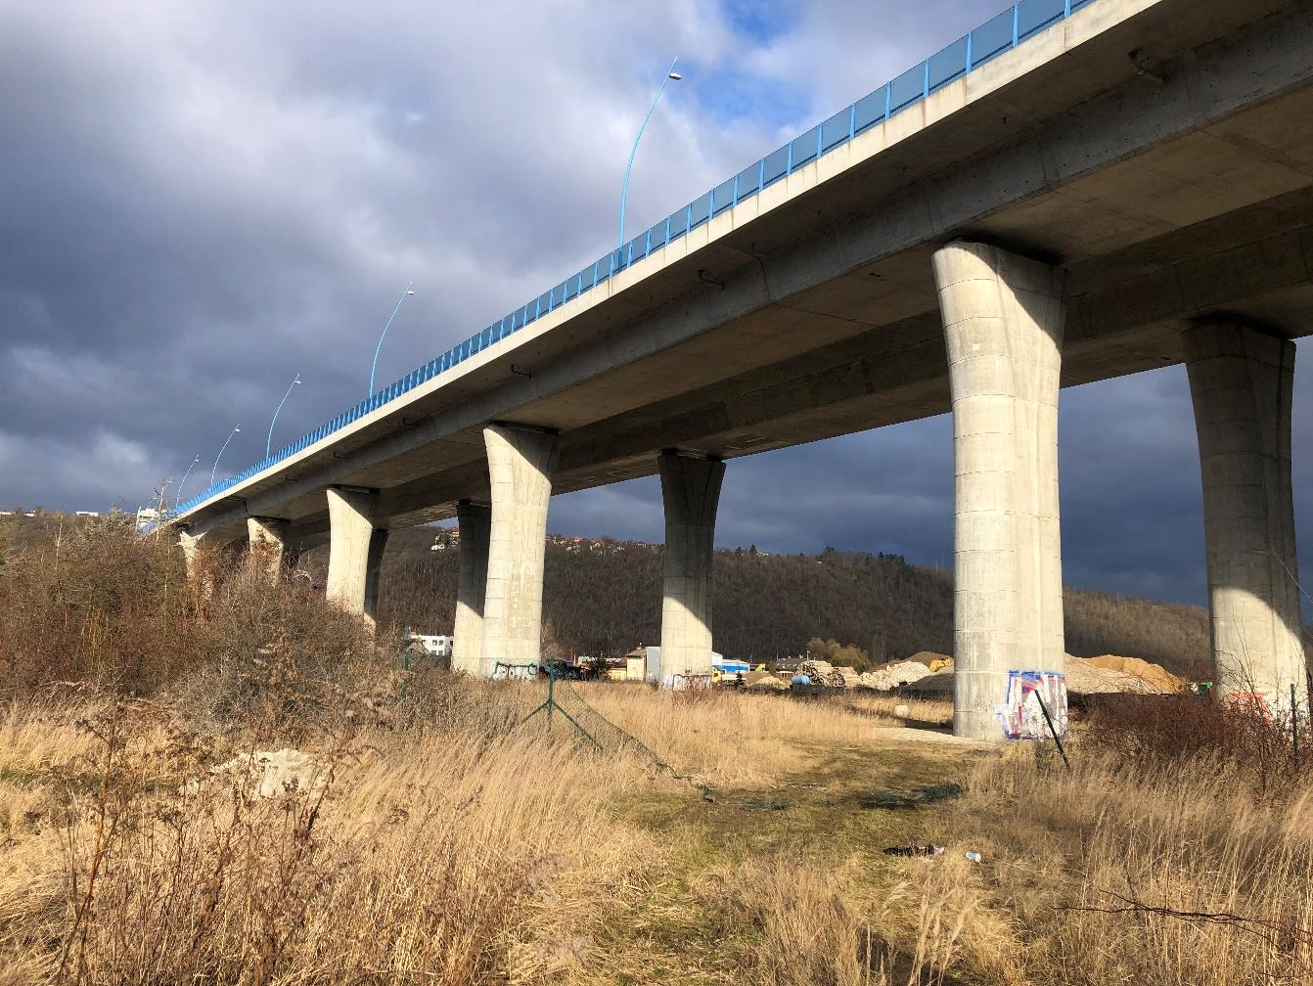
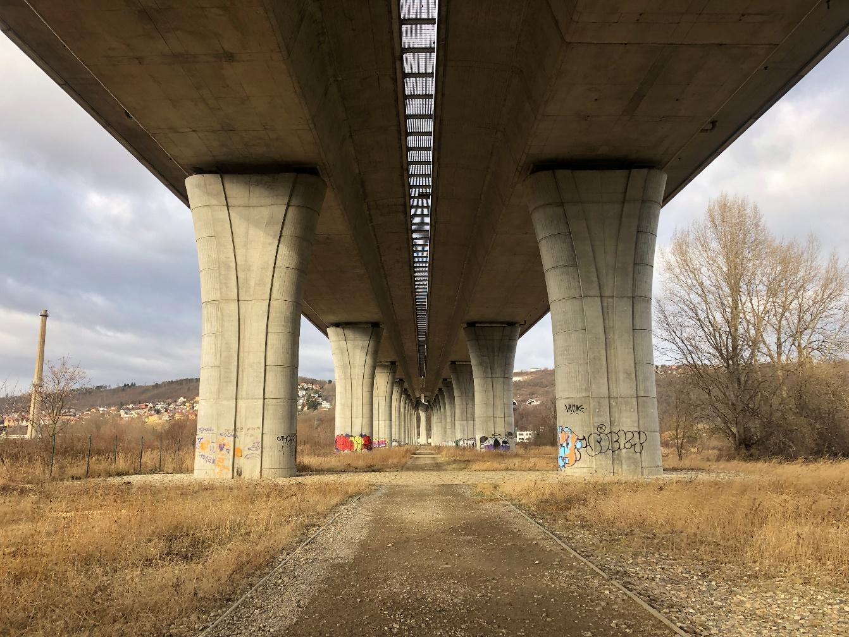
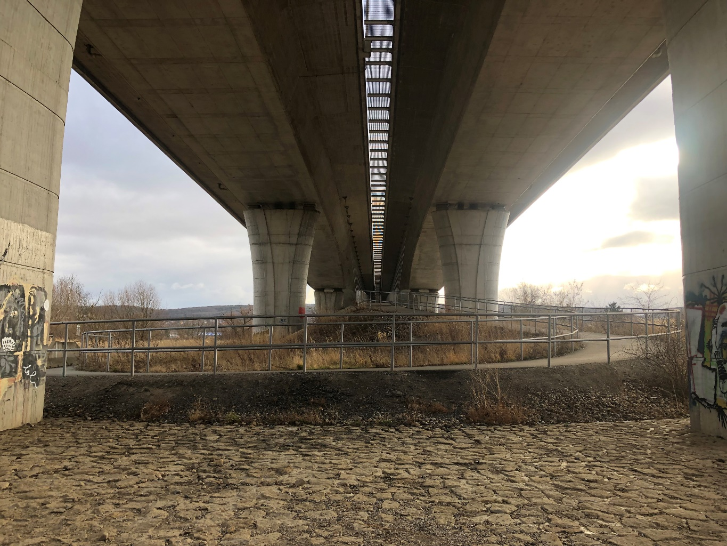
- Shepherd’s Hide
Last possible date of installation: June 2022 (Summer Solstice festival)
The estimated duration of the installation: at least till December 2022. In case of an agreement with the land owner, the duration may be extended.
The maximum budget for the installation is CZK 350,000.
The site, owned by the City of Prague, is located near the intersection of the bike trails under the Lahovice Overpass (Radotín Bridge). The future area of the Sport and Leisure Time Center Radotín is now overgrown with wild-growing trees and ruderal undergrowth. The Prague Institute of Planning and Development was asked for a proposal of a possible use that would ensure the revitalization of the area, and prevent the occurrence of illegal landfills. Obvious options include the clearing of the undergrowth and establishment of a pasture that will provide the basic maintenance of the area, protecting it from further overgrowth. Also the mobile facilities for the Interpretation Centers will be built here, to accommodate the local shepherd – the initiator and facilitator of the educational program “The Pastures and the New Wild”.
The Shepherd’s Hide will be a mobile, artistic and functional object, or a set of objects, primarily used as a shelter, monitoring station, and a place to relax. It will be built on a site owned by the City of Prague, near the Lahovice Overpass, and will accommodate sheep and goats. The building(s)will be used as the shepherd’s/artist’s residence, outdoor meeting area, and shelter/hermitage, offering possible camping near the animals.
Key themes: pastures and the new wild, pasturage as a way of life, the perspective of a herd protector, the need of safety, the solidarity with the ancestors, natural care of vegetation and landscape, cultural and historical traces of land cultivation
Art potential: object installation, art research
Scientific importance: suburban community agriculture, pastures on floodplain meadows in wet locations and forests, pastures and draining of nutrients into rivers, eutrophication impact of pastures and tiny cottages on biodiversity

The location of the area:
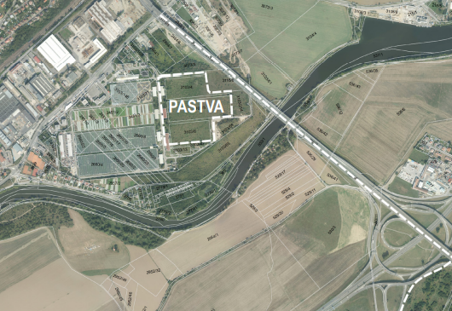
Photos:
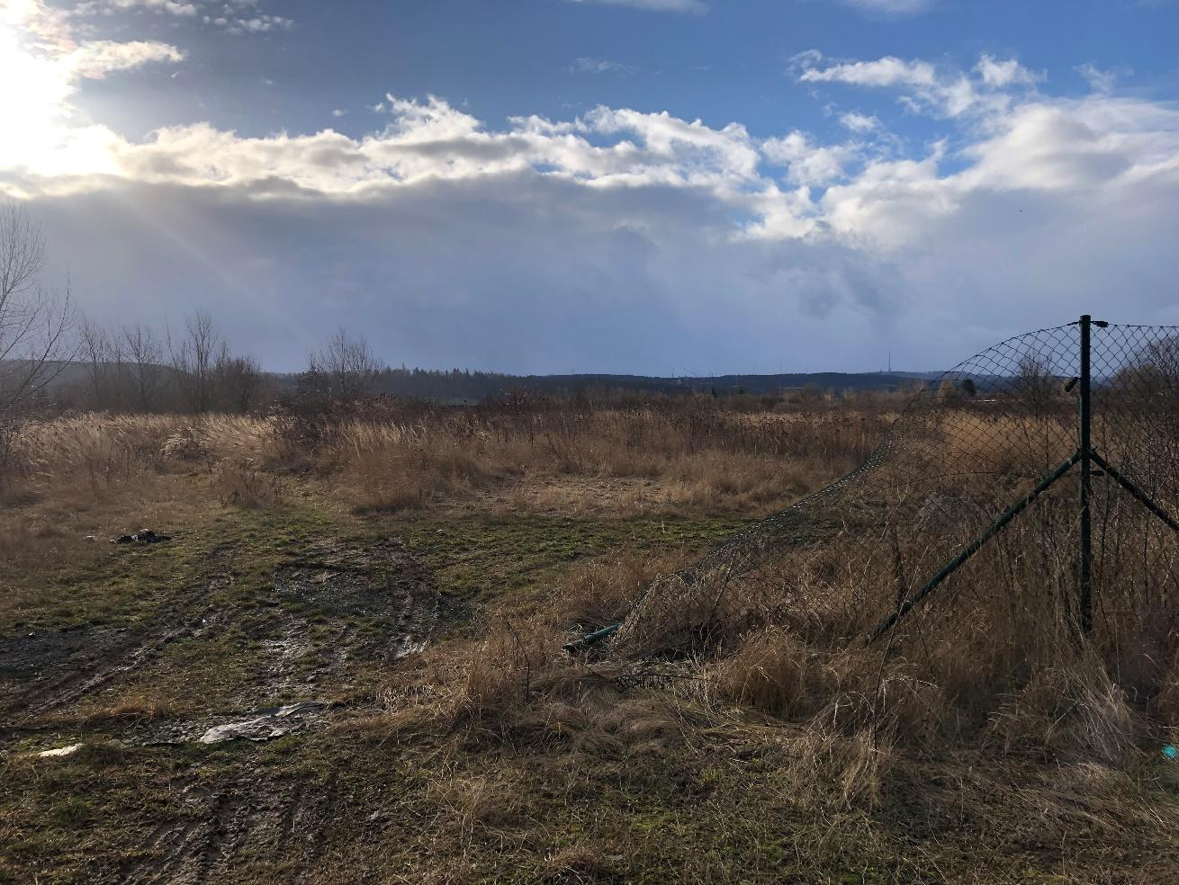

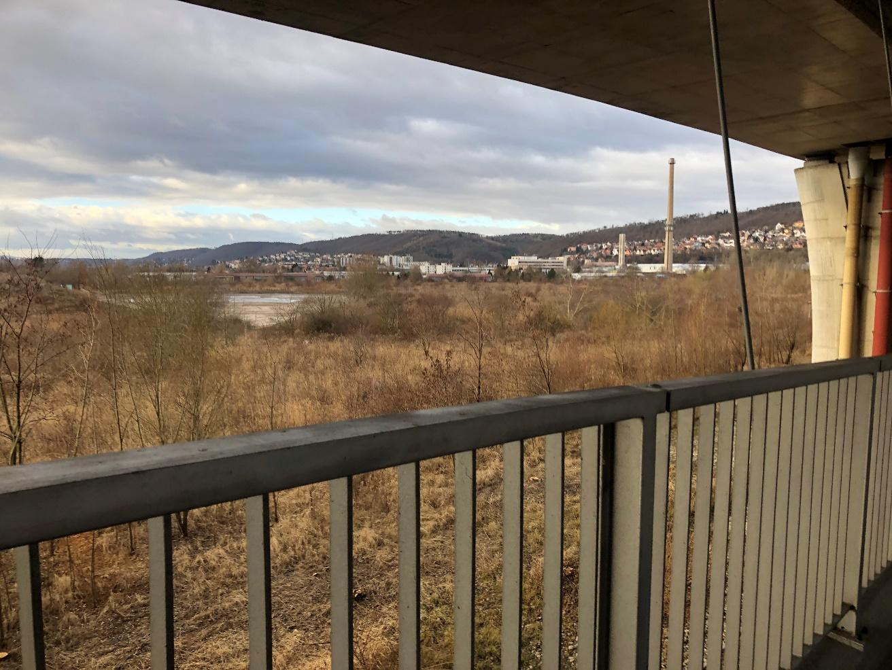

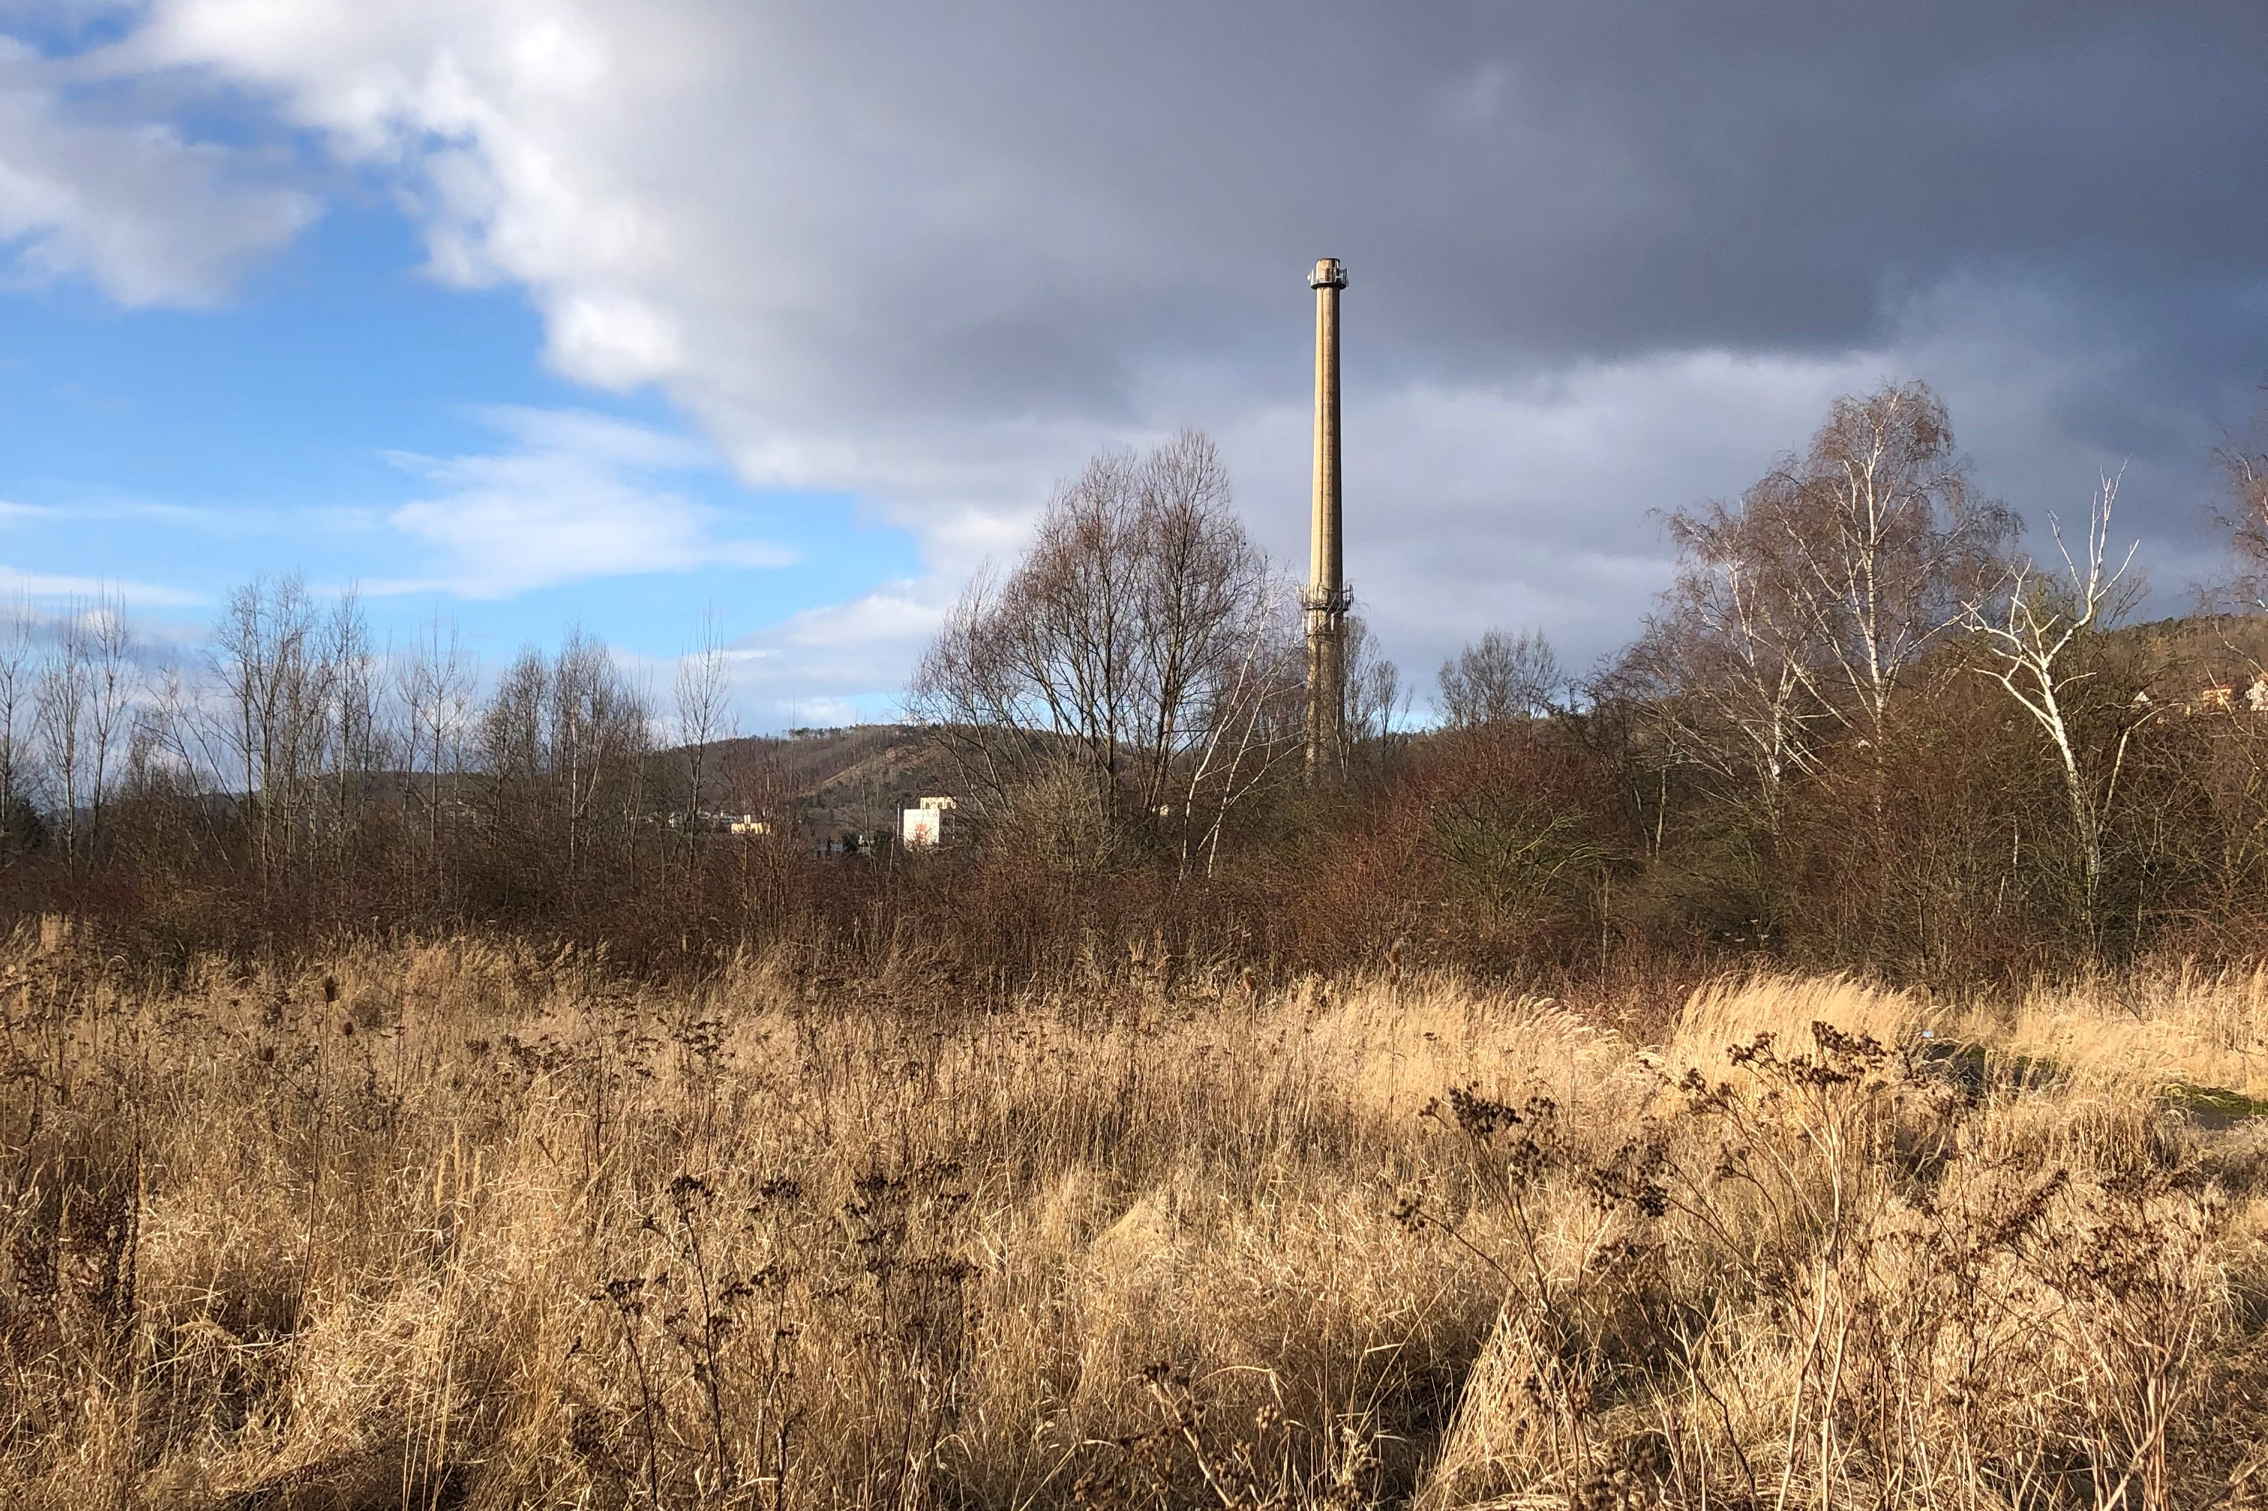

- Lab of Change

Date of installation: June 2022.
The estimated duration of the installation: at least till December 2022. In case of an agreement with the land owner, the duration may be extended.
The maximum budget for the installation is CZK 500,000.
A folding stage, caravan, screen or modular system that can be moved to various places near the confluence of Berounka and Vltava rivers.
The structure will be used for minor cultural festivals as part of the educational program “The Connecting Diversity”. Its design will correspond to specific needs of the scenery at the confluence of Berounka and Vltava rivers.
“The confluence is a prologue and epilogue at once. The starting point to which we will return on important days – solstices and equinoxes.”
The Lab of Change is an interactive object, built so it can be easily moved to another place if needed. The intention (as part of the Confluence Project) is to change the view of the current suburban landscape, and explore its transformation from the fragmented, neglected and underestimated area to the landscape that’s well cared of, protected, and smartly developed. The project investigates the confluence area from various points of view, especially in the perspective of science and humanities, cooperating to prepare the cities to adapt to the climatic change.
Key themes: intellectual understanding of diversity, dialogue across generations, platform for cultural performances, art workshops, education in landscape issues, environmental issues, culture and territorial sociology (The live river – what the river says, Circulation of water in the landscape, The pastures and the new wild, and Landscape as spiritual space).
Art form: model, map, game system of the area, object installation, education tool, blackboard, a study with devices to convey a holistic view of the area.
Scientific importance: Natural elements, such as sandy and gravely banks, undergrowth, flocks of water birds, islands, wetlands, pools and floodplain forests, are integral parts of the river landscape. The natural floodplain without buildings absorbs floods and protects the nearby area, and also helps maintain the biodiversity as a natural migration route of many species. It also improves the self-cleaning abilities of the river. It’s very different to man-made, regulated riverbed.
The floodplains and their borders have often been used as building sites for industrial areas and traffic infrastructure, which has had major impact on the accessibility of the riverbanks. Now, the barriers in the river landscape include discontinued industrial sites, traffic lines and neglected areas, often with large mounds and landfills with growing vegetation that has nothing in common with natural floodplain habitats.
Communication potential: Two different rivers merge to create something new – the model for meeting and connection of two people.
Community potential: active, environmentally sensitive parents; creative workshop for inter-generation dialogue.
Educational program: “The Connecting Diversity“

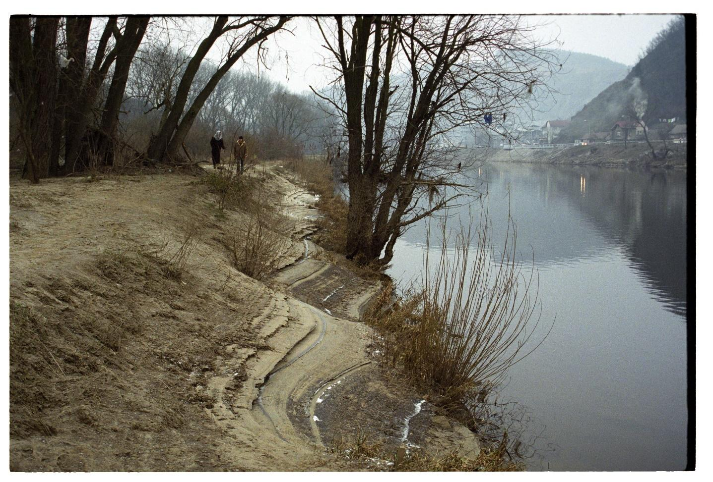

EVALUATION CRITERIA:
- Originality of the artwork (artistic quality and benefit, communication skills of the artwork, author’s concept)
- Local context (use and understanding of the location including historical, cultural and social context)
- Feasibility (respect to the local limits, rules and safety measures, and to people in the public space)
- The committee has the right not to announce the winner and not to recommend any proposal for realization if no proposal fully meets the quality requirements of the committee.
- The committee can also commend more proposals; either announce two 2nd places, or two 3rd places, or give an extraordinary reward to one or more proposals for the specific quality or benefits, up to the total sum of CZK 10,000.

REWARDS:

1) Summer Solstice

the selected proposals will get CZK 10,000 each for the detailed completion of the project for administrative proceedings

2) Shepherd’s Hide
Reward for the 1st place – 20,000 CZK
Reward for the 2nd place – 15,000 CZK
Reward for the 3rd place – 10,000 CZK

3) Lab of Change
Reward for the 1st place – 30,000 CZK
Reward for the 2nd place – 20,000 CZK
Reward for the 3rd place – 15,000 CZK

ANNOUNCEMENT OF THE RESULTS:
The winning and awarded proposals will be announced on April 18, 2022, on the website https://umenipromesto.eu. The authors will be informed by e-mail on the same day.
- The Prague City Gallery considers the submitted projects binding; a contract for work will be signed with the winner. The Prague City Gallery also reserves the right to withdraw from the competition in case of insufficient number of applicants. In case of poor quality of the proposals, the Prague City Gallery reserves the right to refuse the realization. The proposals submitted within the deadline, including the required attachments, will be assessed by the Committee consisting of art theoreticians, curators, architects and representatives of the Prague City Hall, city districts and location owners. There is no appeal possible against the decision of the Committee.
- The lineup of the Committee will be published on the website of the project “Art for the City”: https://umenipromesto.eu until March 7, 2022.
- A written record will be made the meeting of the Committee, including the list of all evaluated artworks and the verdicts. The record will include the list of all attending Committee members, with their signatures. The meeting of the Committee isn’t publicly accessible.

OTHER PROVISIONS
The selected proposals will be realized in cooperation with local stakeholders and representatives of the Technology Agency research team. The selected proposal will be completed and realized in the community dialogue between the author and the researchers of the project “Interpretation of Landscape Aspects Through Humanities and Art”.

CONTACT INFORMATION:

In case of any questions, please feel free to contact us at umenipromesto@ghmp.cz and anna.gumplova@ghmp.cz. You can also arrange for a personal consultation via e-mail, or ask for details regarding the conditions, or for assistance in making the presentation.

Important dates:

  - Announcement of the call: February 21, 2022
  - Deadline for proposals: April 7, 2022 (until 12 AM)
  - Announcement of the results: April 18, 2022

